Assignment # 04

Ayesha Iftikhar

FA17-BSE-011

# Question #01:

**What is CMMI and explain the levels?**

## CMMI:

* The **Capability Maturity Model Integration (CMMI)** is a process and behavioral model
* Which helps organizations streamline process improvement
* And encourage productive, efficient behaviors that decrease risks in software, product, and service development.
* The Software Engineering Institute developed it at Carnegie Mellon University as a process improvement tool for projects, divisions, or organizations.
* The DoD and U.S. Government helped develop the CMMI, a common requirement for DoD and U.S. Government software development contracts.
* It is currently administered by the CMMI Institute, which was purchased by the ISACA in 2016.

## Levels of CMMI:

The CMMI model breaks down organizational maturity into five levels, which are:

* **Initial:** Processes are viewed as erratic and reactive. At this stage, "work gets accomplished, but it's often delayed and over budget." this is often the worst phase a business can find itself in — hit or miss environment that increases risk and inefficiency.
* **Managed:** There's A level of project administration achieved. Projects are "planned, performed, measured, and measured" at this level, but there are still tons of issues to deal with.
* **Defined:** At this stage, organizations are more practical than reactive. There's a group of "organization-wide standards" to "guide projects, programs, and portfolios." Businesses understand their shortcomings, the way to address them, and what the goal is for improvement.
* **Quantitatively managed:** This stage is more unhurried and controlled. The organization is functioning off quantitative data to work out predictable processes that align with stakeholder needs. The business is before risks, with more data-driven insight into process deficiencies.
* **Optimizing:** Here, an organization's processes are steady and versatile. At this end, a corporation will continuously be improving and answering to changes or other opportunities. The organization is steady, which allows for more "agility and innovation" during a predictable environment.

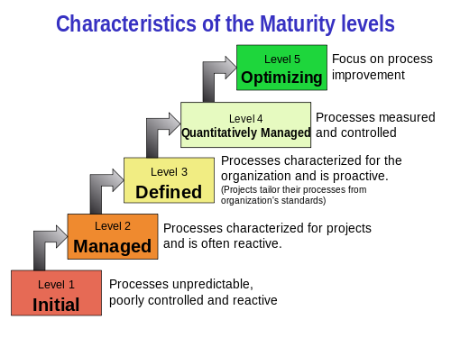

# Question #02:

[**What are the similarities and differences of CMM vs. CMMI?**](https://www.researchgate.net/post/What_are_the_similarities_and_differences_of_cmm_vs_cmmi)

## Similarities:

* Both CMM and CMMI are used to improve the process of software development.
* Both have five levels.

## Differences:

* CMM is a certification tool, while CMMI is not.
* CMM came first but was later enhanced and was succeeded by CMMI.
* CMMI is [much](http://www.differencebetween.net/language/difference-between-much-and-many/)more beneficial and universal than the older CMM.
* Initially, CMM describes software engineering specifically, whereas CMMI describes integrated processes and disciplines as both software and systems engineering.

Key factors that distinguish both are as follows:

* **Integration:** The CMM has individual models for each function. But when the unique processes when integrated led to few discrepancies like a model overlapping, contradiction and each model had its maturity level, leading to confusion. This led to an increase in the costs of the companies that were put in training. But CMMI employs models that are classified based on specific areas of interest. These models are those employed by industries successfully. To engage CMMI in an organization, it must choose a model from the available 22 models wherein each module covers all the functionalities.
* **KPA**: Both CMM and CMMI have five maturity levels. But there are changes in the KPAs of each maturity level. The alterations in each model are as follows:
  + **Initial:** In both models, it concealments the organizations without defined processes, having dynamic variations (ad-hoc) and undocumented.
  + **Repeat:** In CMM, the companies that look to do the same process sometimes attain this level. It requires a planned and defined way of managing the requirements by estimating CMMI's cost, time, and resources.
  + **Defined:** CMM needs a standard, well-documented, and consistent process with few degrees of changes to be followed. CMMI necessitates the process to be standardized, methodical, and procedural with the use of tools.
  + **Manage:** CMM requires companies to measure and monitor process thereby reducing risks quantitatively. CMMI, in addition, identifies and monitors the sub-processes that donate to overall efficiency.
  + **Optimized:** In CMM, the process is unceasingly enhanced by following the best software engineering practices but here, the measures are taken concurrently as the goals are satisfied. In CMMI, the behavior is selected, and plans are set to support it. Behaviour is chosen based on goals and measures.
* **Approach:** CMM is an activity-based model. It aims only after the process and does not care about the anticipated result, and hence it does not stimulate the company to make the necessary changes. But CMMI is result-oriented based on key performance areas, and thereof it is a best practice for the companies and helps avoid the possible risks at a very early stage.
* **Paper Work:** Both CMM and CMMI documentation has paperwork and meetings that waste the personnel's effort and time. However, CMM is process-oriented, whereas the CMMI is a goal-cum-result-oriented approach.

# Question #03:

**Which CMM Level is best? Why is CMMI important for the organization?**

## The best level of CMMI:

Level 5 of CMMI is the best as it is more beneficial for the organizations and clients.

## Importance of CMMI for Organizations:

The [Software Engineering Institute](http://www.sei.cmu.edu/) (SEI), at Carnegie-Melon University, introduced by the U.S. Department of Defense. SEI has long been the organization that not only researches and recommends development improvements, processes, and practices but offers an independent and objective "appraisal" as to whether an organization is actively practicing these standards. It is essential because it is beneficial in two ways defined below:

* The expectation of Sustainment for the long haul
* A balance between efficiency and process by aligning our internal processes with the Process Areas called out in the CMMI guidance.

Repeatability is the significant to process success, and as they have now become the norm and not painful, everyone is in sync with the expectations.